

Parent-Child and Grouping

# Lecture’s Checklist



1. Parent-Child
2. Adding Siblings
3. Multiplication
4. Grouping

# Parent-Child

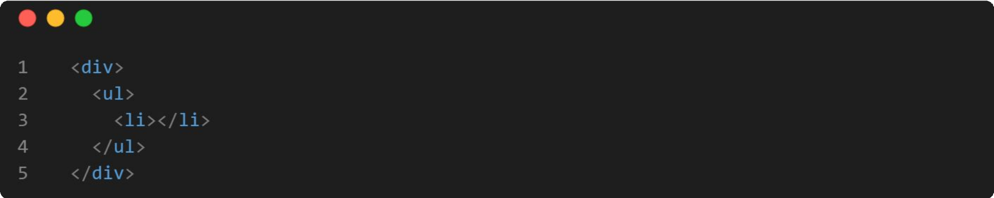

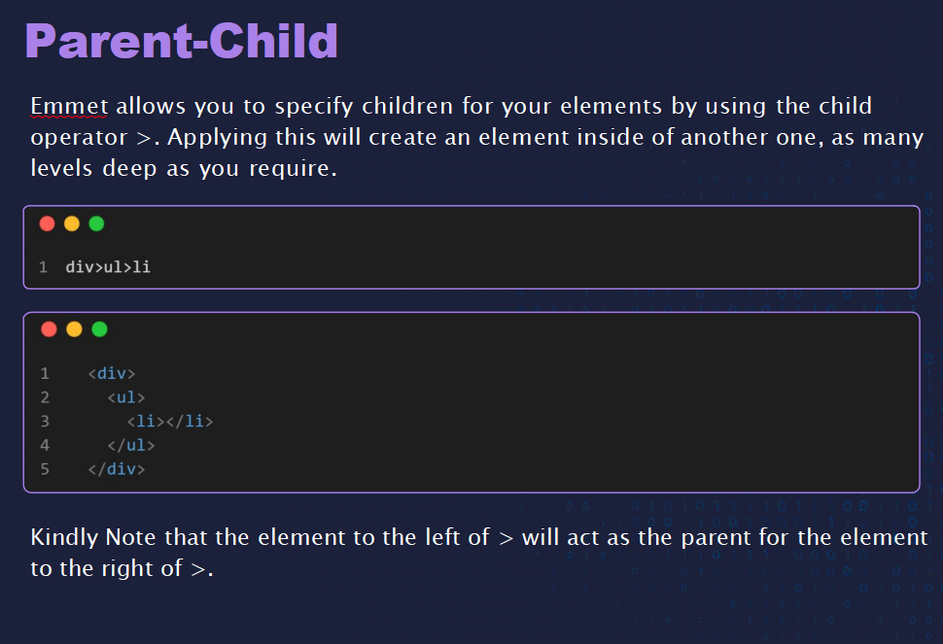

Emmet allows you to specify children for your elements by using the child operator >. Applying this will create an element inside of another one, as many levels deep as you require.

Kindly Note that the element to the left of > will act as the parent for the element to the right of >.

# Adding Sibling

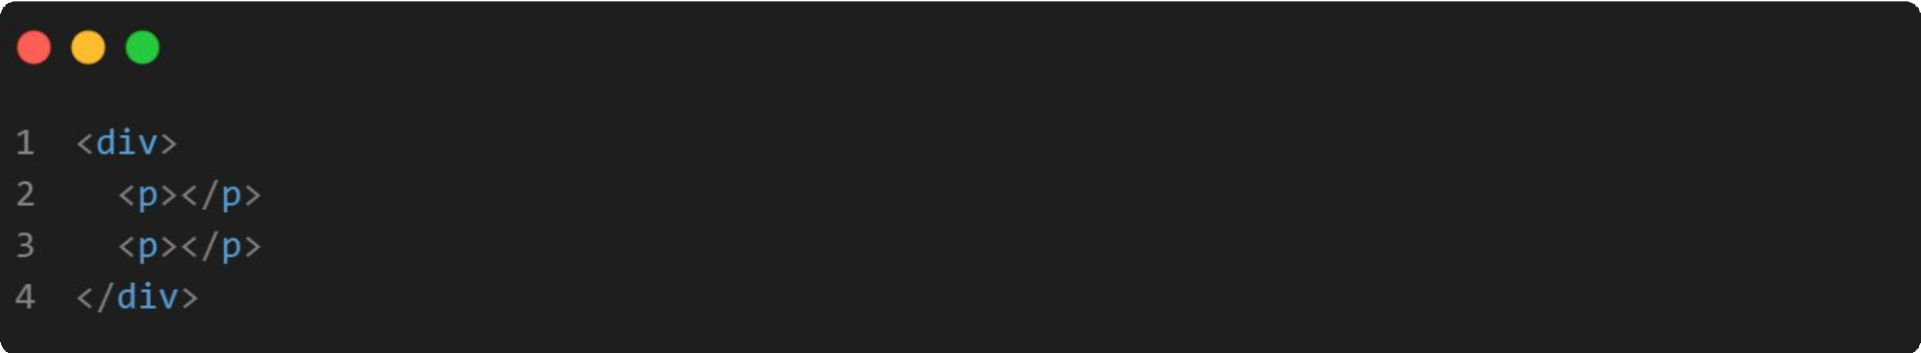

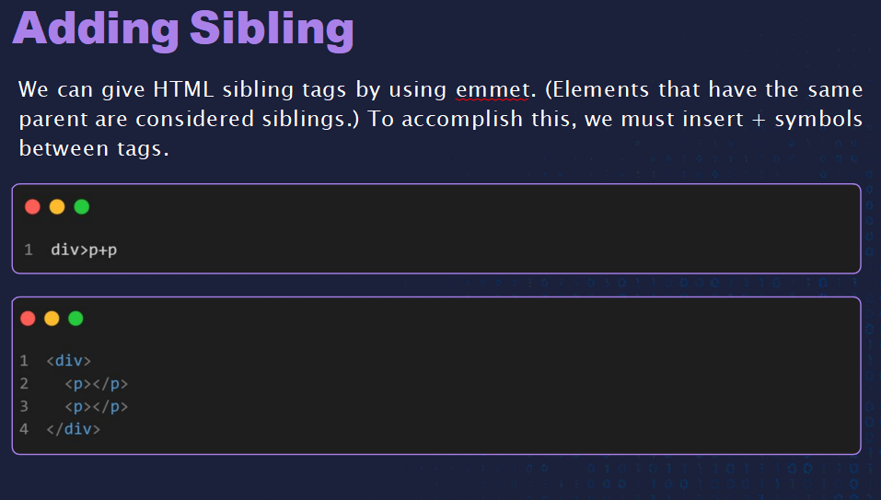

We can give HTML sibling tags by using emmet. (Elements that have the same parent are considered siblings.) To accomplish this, we must insert + symbols between tags.

# Multiplication

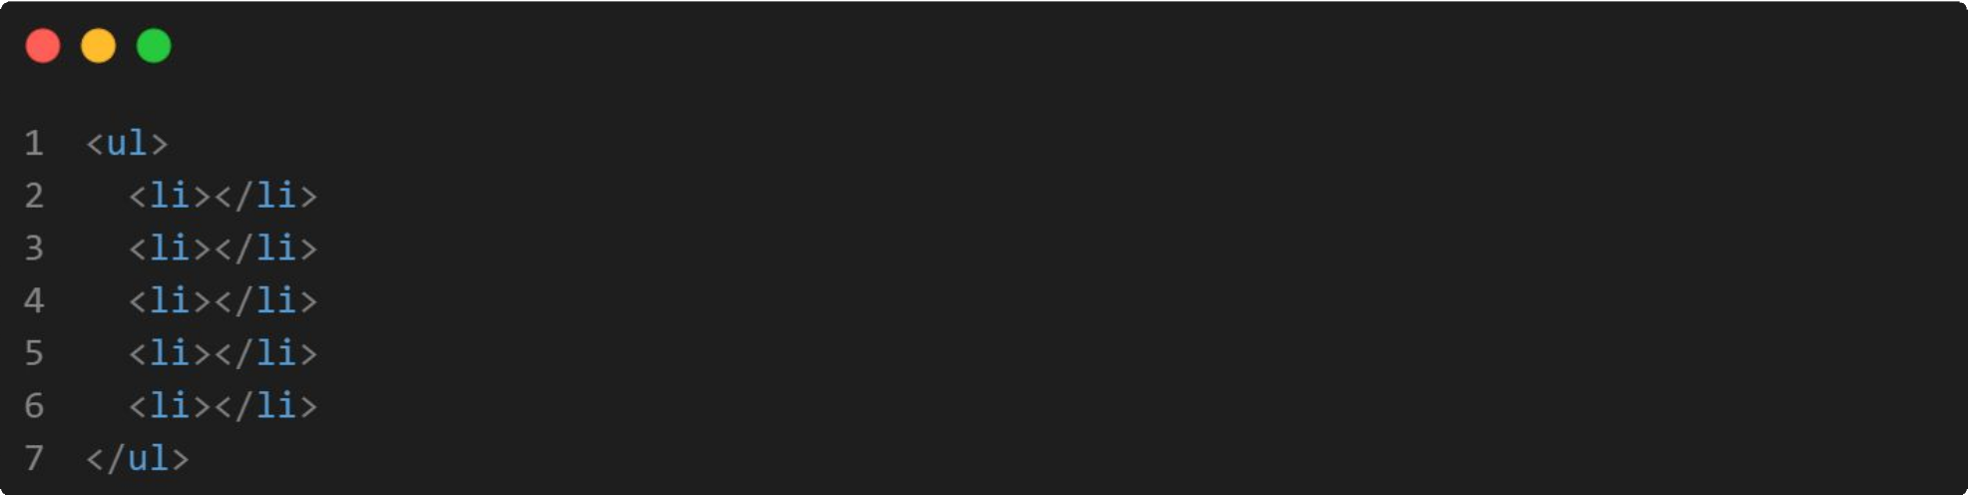

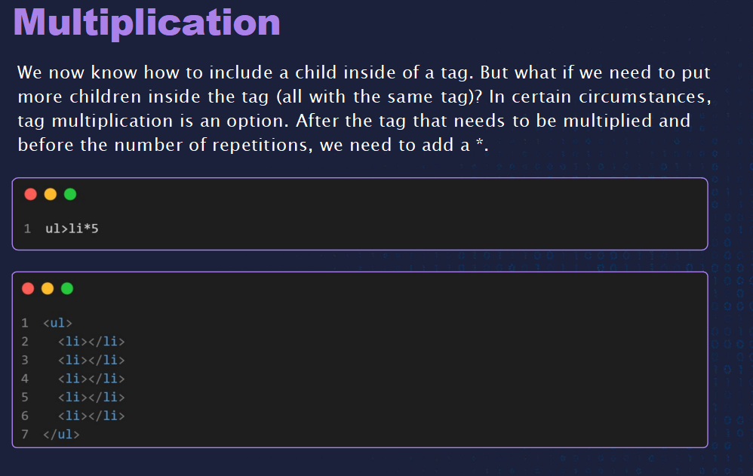

We now know how to include a child inside of a tag. But what if we need to put more children inside the tag (all with the same tag)? In certain circumstances, tag multiplication is an option. After the tag that needs to be multiplied and before the number of repetitions, we need to add a *.

# Grouping

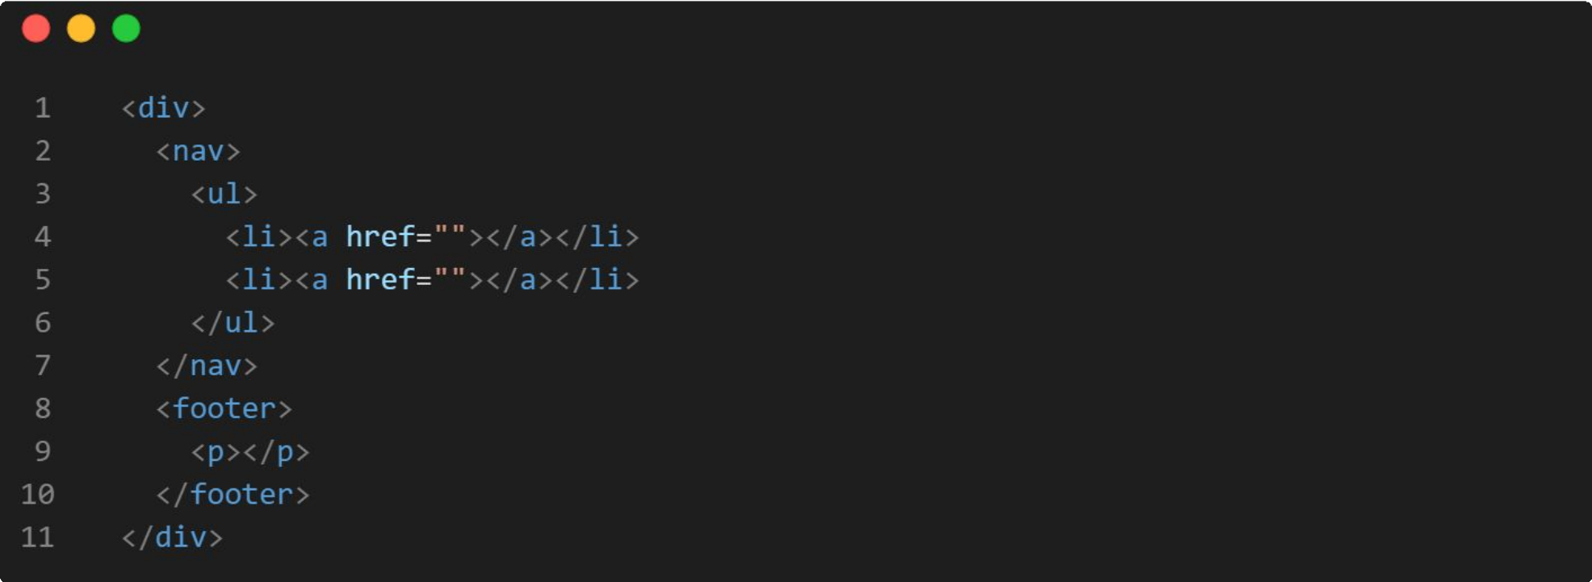

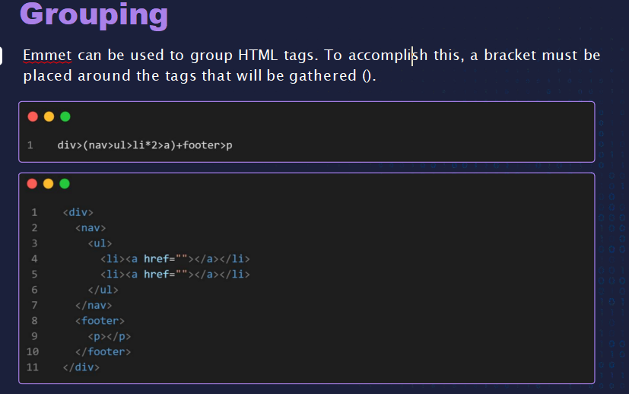

Emmet can be used to group HTML tags. To accomplish this, a bracket must be placed around the tags that will be gathered ().



**THANK YOU**